NOTE TO SPEC WRITER: Include the following sections for RTC Funded Projects only. RTC is only wanting these for ROW 80’ or greater or if there are no CCTV near. Recommendation for which devices should be bid and the number of days for each device should come from RTC. Any questions during the bidding process should be directed to RTC.

SECTION 635 – WORK ZONE ITS
DESCRIPTION
635.01.01 GENERAL
- This work shall consist of providing, deploying, and maintaining technology within the project work zone that will provide pertinent device information, facilitate coordination with other active work zones, and increase the effectiveness of work zone traffic operations. Work Zone ITS is made up of several devices, supporting systems, and software.
- The Contractor shall be responsible for the safety of all Work Zone ITS materials and shall take all necessary precautions to avoid loss or damage due to theft, vandalism, environmental conditions, unauthorized use, or other work zone hazards and shall bear the cost of replacing any component that is lost, destroyed or damaged.
MATERIALS
635.02.01 GENERAL
    - All Work Zone ITS equipment components that are intended to be located outdoors shall meet the following environmental requirements:
      - System device components shall be NEMA-3R (rainproof and sleet resistant) or IP22 (protection against solid objects over 12mm and against direct spray up to 15 degrees from vertical) rated for outdoor use.
      - System device components shall meet NEMA TS1/TS2 Environmental requirements for temperature.
      - System device components that don’t meet the above NEMA TS1/TS2 and NEMA-3R or IP22 shall be mounted within a NEMA-3R or IP22 rated enclosure that provides a ventilation system (e.g., temperature sensor, ventilation fan, dust filters, etc.) of sufficient capacity to prevent equipment inside from overheating or be explicitly designed to withstand and operate in seasonal high temperatures for the project area. The design of the provided capacity of this ventilation system shall account for the heat radiating from the enclosure mounted equipment and the historically high temperatures encountered within the summer season in Clark County, NV.
    - Real-time GPS tracking is required on each device herein to inform remote system users of the location where the device is deployed and shall be shown on a single mapping interface to be determined by the RTC. The format of the data feed shall be Extensible Markup Language (XML), with a known schema coordinated with and approved by the RTC. The XML data shall be made available for RTC via an access through standard internet connectivity and services, with the provision of a data feed address, port (if applicable), and authentication/sign-on parameters. Real-time location shall be updated every 15 minutes at a minimum. The GPS locating device shall provide location data within 3 meters (9.84 feet) or less of the actual location. Each device location shall be uniquely identified on the map with a device type symbol and unique nomenclature for each device location. The map shall include a legend that identifies the device type symbols and the associated device function.
    - All cameras shall have capabilities for remote viewing photos, at designated time intervals, or video streams by agencies, including RTC, FAST TMC, agency responsible for approving the traffic control plans, and by construction personnel, to monitor the work site, construction activities, and traffic conditions along the project corridor. All camera images and video streams shall be available remotely through a single software platform using a standard internet connection and services, with the provision of a data feed address, port (if applicable), and authentication/sign-on parameters. Each camera shall be uniquely identified on the RTC mapping interface using camera device type symbols (i.e., Fixed and PTZ) and a unique nomenclature for each camera location.
    - All Work Zone ITS devices shall be provided with the necessary wireless communications equipment, FCC licensing, network services (i.e., cellular, WiFi, satellite, and internet network service plans), and other requirements as necessary to continuously operate and maintain a complete Work Zone ITS system. It shall be the Contractor’s responsibility to perform a site assessment of the project area and pick a cellular network provider that has sufficient data network capacity and coverage needed for this project. The Contractor shall submit to the engineer for approval a Cellular Communications Site Assessment Summary document identifying the project areas evaluated, the cellular network provider selected, and a statement indicating that there is sufficient data network capacity and coverage needed for this project.
    - All Work Zone ITS devices and system shall be independently powered for operation continuously during all traffic control operations deployed in the project area. This power distribution assembly shall include intelligence for monitoring the remaining power level of the batteries and shall send a "critically low power" type alarm message, to the remote system server. The "critically low power" level selected shall provide enough time for the contractor to replace/recharge the device/batteries before the device has a power failure.
    - All portable device trailers shall be capable of transporting all the necessary system elements and capable of mounting fully functional Work Zone ITS devices along the roadside. Each device trailer shall provide the following common elements:
      - A trailer number that is unique (e.g., trailers deployed in the project area shall not have the same number as other deployed trailers) and is visible from the first vehicle travel lane adjacent to the deployed trailer.
      - All necessary cables, power supplies and communications devices needed for interconnecting the trailer mounted devices shall be provided. Cable mounting provisions shall be provided within the trailer for securing cables during system operation and during transport to a different location.
      - Mounting provisions for all associated trailer mounted devices. Mounting provisions shall include mounting of devices for deployment within the work zone and mounting provisions for hauling all associated trailer mounted devices from one location to the next without needing a separate vehicle to transport any of the components that are intended to be mounted on the trailer.
      - The device trailer shall be street legal, have functioning brake lights connected to it when being towed, capable of being towed at high speeds, and provided with a standard size trailer hitch.
      - The device trailer shall have adjustable leveling legs that can completely support the weight of a fully loaded trailer. The adjustable height of the legs should be able to raise the trailer wheels a minimum of four inches between the bottom of the wheels and a flat/level surface that the trailer is standing on. The device trailer shall have a minimum of two-level gauges (length and width positions) to indicate when the trailer is level.
      - When in operation with all stabilizing devices in place, the device trailers shall be capable of withstanding wind gusts of up to 80 mph without overturning or changing orientation.
    - The specific deployment location of each device shall be coordinated with and approved by the Engineer and agency responsible for approving the work zone traffic control plan. Devices locations shall not protrude into the vehicle realm of any work zone. The following figures are graphical scenarios that demonstrate typical intent of device locations. Exact locations will be will be determined at the preconstruction meeting.

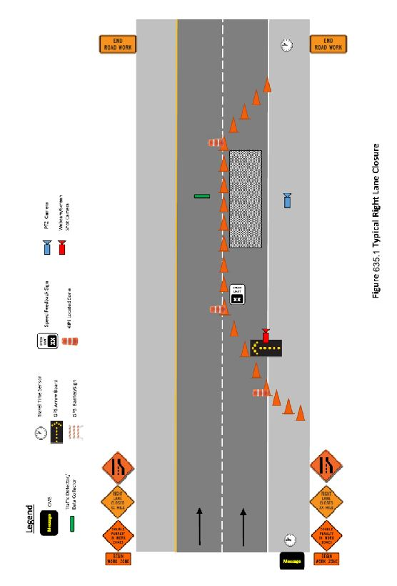
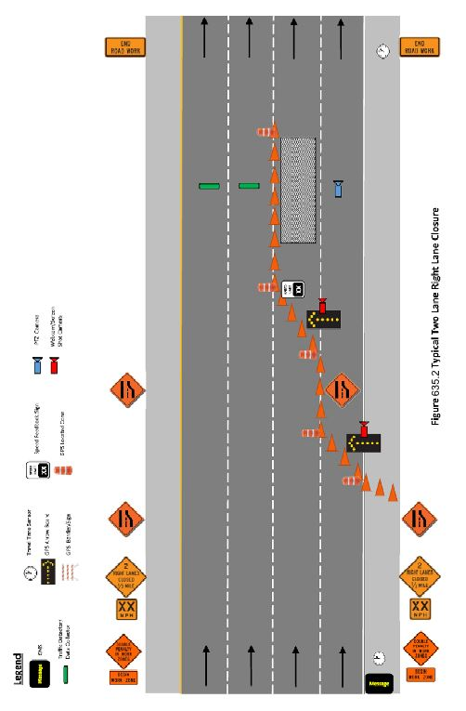
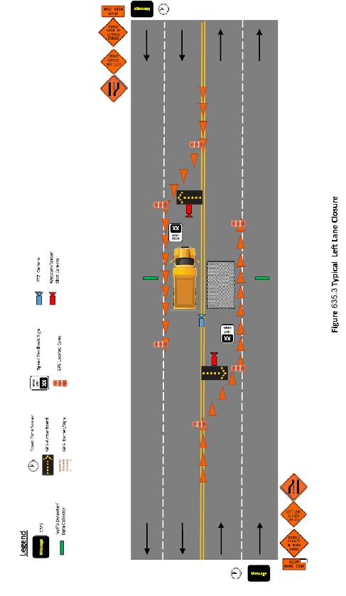
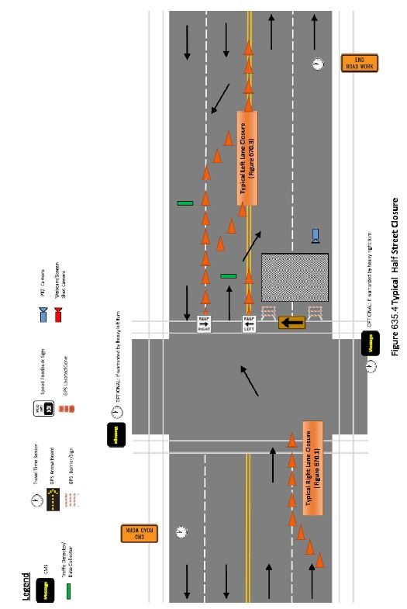
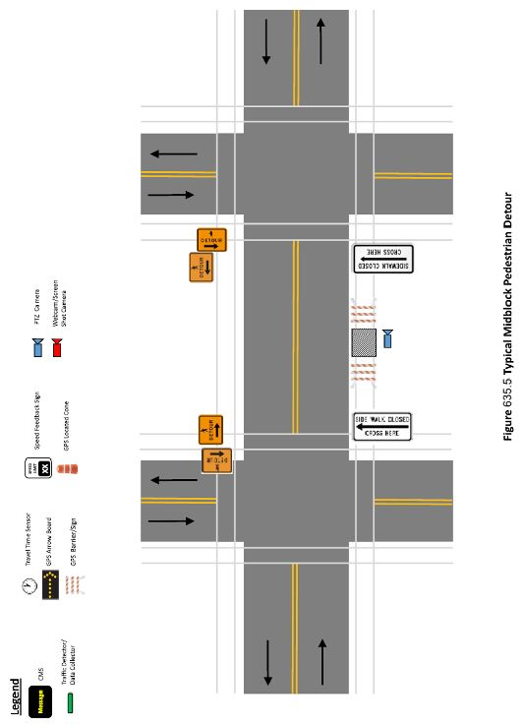
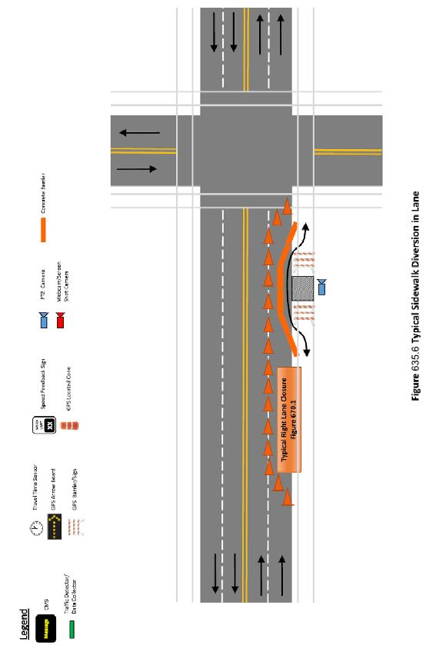
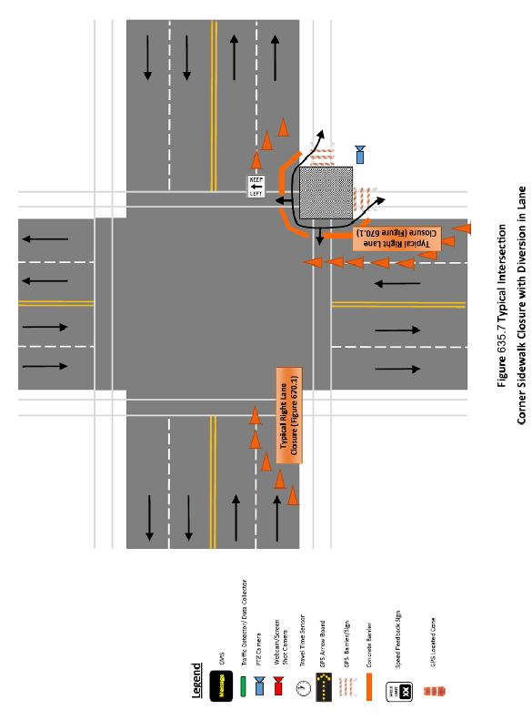
635.02.02 VEHICULAR TRAFFIC DETECTION ZONE
    - The functional requirement of this item shall be to collect vehicle count, presence, speed, and flow data of vehicles passing through the work zone. Required deployment and calibration of the sensors by work zone field personnel shall be minimal, i.e. deployment and calibration shall not require specially trained personnel. A bulleted list of calibration instructions shall be given. The intent of the required efficiency for deployment of the system is set up so that it does not cause delays to the project work.
    - Each detection zone shall be configured to provide vehicle count, presence, speed, and flow data. The selection of which traffic detection sensor system manufacturer(s) and model number(s) provided shall account for the manufacturer’s recommended offset distance from nearest travel lane while still achieving reliable detection data in the travel lane(s) it is deployed for.
    - The traffic detection technology used shall be provided and integrated with a cloud-based Work Zone ITS system software for remote control/monitoring and shall collect, process, and archive traffic data every three minutes, at a minimum, and provide functionality to send email alert messages when user configurable traffic thresholds occur.

635.02.03 PTZ CAMERA
    - A camera shall be provided with Pan-Tilt-Zoom (PTZ) functionality for remote monitoring of work zone conditions, video analytics for real-time status alerts of pre-programed thresholds, and a cellular network router used for remote communications and GPS tracking of the camera deployment location.
    - Camera shall be mounted to a telescoping pole that provides a minimum height of 20 feet.
    - Camera shall feature at a minimum the following capabilities:
      - 20x zoom
      - 60 frames per second
      - 2 mega pixel or full high definition
      - Auto/manual day and night visibility
      - High speed PTZ
635.02.04 GPS ARROW BOARD
    - An arrow board is typically required in traffic control plans to provide advance notice of lane closures and direct traffic to merge right or left. The typically used board is modified to add remote status monitoring, still shot digital camera, and GPS tracking functionality.
    - Each GPS arrow board shall have a camera mounted on the back of the arrow board oriented in the direction downstream from the arrow board to monitor activity at the work site. The camera shall have the minimum capability of sending pictures at regular intervals, typically every 15 minutes. Sending video streams and providing PTZ capabilities are acceptable but not required to keep power and communication requirements low. The camera shall be mounted near the top of the board for maximum field of view. Camera provided shall feature at a minimum the following capabilities:
      - 2 mega pixel or full high definition
      - Auto/manual day and night visibility
    - The arrow board shall provide a cellular network router used for remote communications and real-time GPS tracking to inform remote system users of the arrow board location, when deployed within the work zone, and shall also indicate which direction to merge or which lane is closed.
635.02.05 GPS LOCATED TRAFFIC CONTROL DEVICE
    - The GPS tracking device on a traffic control device informs remote system users of the device location. These devices include but are not limited to:
      - GPS Located Begin and End Work Zone Indicator
      - GPS Located Barricade and Signs
      - GPS Located Flagger
    - GPS location of begin and end work zone indicator shall provide specific location of first traffic control device (cone) and last traffic control device (cone), each with a unique symbol identified in the legend and unique nomenclature for each device location on the RTC mapping interface.
    - The GPS tracking device on a barricade and signs informs remote system users of work zone device locations and/or traffic restriction conditions. GPS located barricades and signs shall be placed where barricades and signs are typically placed where identified and required on the traffic control plans for street closures, half street closures, and on both approaches to sidewalk closures. There shall be a unique symbol identified in the legend for closure type (i.e., street, half street, and sidewalk closures) and unique nomenclature for each device location on the RTC mapping interface.
    - The GPS tracking device on a flagger informs remote system users of work zone device locations and/or traffic restriction conditions that require a flagger. GPS located flagger shall be placed where identified and required on the traffic control plans. There shall be a unique symbol identified in the legend for an active flagger location and unique nomenclature for each device location on the RTC mapping interface.
635.02.09 TRAVEL TIME TRAFFIC ANALYTICS SYSTEM
    - Travel time traffic analytics are systems which provide travel time data through the work zone in both travel directions. This system generates data that can be used for pre-Work Zone ITS deployment planning activities, as well as before/during/after evaluations. The system can be provided using cloud-based crowd sourced data or anonymous re-identification device (ARID) sensors. Travel times shall be provided in real-time, via a cloud-based Work Zone ITS software system, operator interface during construction when temporary traffic control devices are deployed, and travel times shall be archived for before/during/after evaluations of the project area.
    - If ARID sensor(s) are used they shall detect the Bluetooth and WiFi signals in both travel directions from vehicles, hands-free sets, mobile phones, and navigation systems. Placement shall be the contractor’s responsibility. Existing traffic signal cabinets will not be available for housing sensors.
    - The Travel Time Traffic Analytics technology used shall be provided with and integrated with a cloud-based Work Zone ITS system software for remote control/monitoring and shall collect, process, and archive travel times every three minutes, at a minimum, and provide functionality to send email alerts when travel time thresholds occur.
635.02.10 SPEED FEEDBACK SIGN
    - The speed feedback sign detects and displays real time vehicle speeds and functions as a speed data collection point.
    - Receive detector speed data using three-minute averages, at a minimum, for each location.
    - Provide a system algorithm that automatically displays the current speed of the vehicle that is currently within the detection zone.
    - Through the Work Zone ITS Software GUI, project stakeholders shall have the ability to monitor the status of the devices and if applicable for device set any threshold levels which will trigger a change in the speed display state (solid or flashing) and a change in color of the device symbol in the GUI to yellow when the device reading is at or below the threshold and changes the color to red or blue when the device reading is above the speed threshold.
    - The GPS tracking device on the speed feedback sign informs remote system users of the device location using a unique speed feedback sign symbol identified in the legend and unique nomenclature for each device location on the RTC mapping interface.
635.02.11 WORK ZONE ITS CHANGEABLE MESSAGE SIGN (CMS)
    - The Work Zone ITS CMS may be the first Work Zone ITS device that a driver will encounter prior to the beginning of the work zone. There are two (2) Work Zone ITS CMS locations, one for each direction of travel. Work Zone ITS CMS devices are deployed where there is an option for drivers to take an alternate route and thus avoid the work zone entirely. The message displayed on the Work Zone ITS CMS is intended to provide information to drivers regarding the conditions of the work zone, such as congestion or crashes, delay time, and available alternate routes to allow drivers to make informed routing decisions.
    - The Contractor shall provide Work Zone ITS CMS devices as a fully functional system component that includes the following elements and meeting the applicable performance requirements identified in this section:
      - One portable device trailer for each Work Zone ITS CMS location capable of transporting and mounting all the necessary system elements.
      - A CMS mounted to a trailer with mounting bracket to adjust the field of view from the variable message display sign. The variable message display area shall display messages that are compliant with MUTCD Section 6F.60 - Portable Changeable Message Signs and display three lines of eight characters per line with each character a minimum size of five pixels wide by seven pixels high. The size of the characters shall be adjusted to correspond with industry recommended sizes for the actual speed limits posted, in the signs field of view, per the approved traffic control plans and shall accommodate speed limits up to 50 mph. The signs should be visible from 1/2 mile under ideal day and night conditions. Under low light level conditions, the sign shall automatically adjust its light source to meet the legibility requirements and not impair the driver’s vision. The pixels shall be constructed with Light Emitting Diodes (LEDs). The LEDs within the sign shall be visible to drivers that are in front of the sign and within a 30-degree cone of view from the sign.
      - The Work Zone ITS CMS system shall use historical travel time data (provided under Travel Time Traffic Analytics System) compared against current travel times and shall automatically generate the delay times and other types of messages for display on the CMS, based on pre-set threshold triggers for each type of display message.
      - The GPS tracking device on the Work Zone ITS CMS informs remote system users of the device location using a unique Work Zone ITS CMS symbol identified in the legend and unique nomenclature for each device location on the RTC mapping interface.
635.02.12 VEHICLE PRESENCE ALERT SYSTEM
    - The Contractor shall provide a flashing light transponder for light bar equipped work vehicles to broadcast warnings or presence to other vehicles during construction. This transponder shall send location and status information to the RTC mapping interface and Waze interface. The vehicle presence alert system shall be synchronized with the light bar to allow for passive operation by the contractor. Activation of the light bar by the vehicle operator shall prompt the automatic activation of the device, and the device shall automatically deactivate with deactivation of the light bar. No other steps shall be required for the system to function.
    - The functionality of the alerts shall be as follows:
      - Location pin to be displayed on RTC mapping interface and Waze interface when light bar is flashing, and vehicle is stationary for approximately one (1) minute.
      - When vehicle is in motion, the Waze pin will be deactivated.
      - Each vehicle set up with “Vehicle Presence Alert System” shall be designated in Waze as “Construction Vehicle.”
      - Each vehicle detection location shall be uniquely identified on the RTC mapping interface a unique “Construction Vehicle Present” symbol in the legend and unique nomenclature for each vehicle deployed within a work zone. Vehicle location must be static for a predefined period for the location to be displayed on the RTC map.
635.02.13 WORK ZONE ITS SYSTEM SOFTWARE AND PERFORMANCE REQUIREMENTS
    - The Contractor provided Work Zone ITS systems shall be comprised of the following standalone systems or integrated together as one complete operational system. The software to operate each shall be full service software system to provide the required deployment controls, data collection, notices, alerts, and access to the RTC and other project stakeholders at a minimum for the following:
      - Vehicular Traffic Detection Zone System
      - PTZ Camera System
      - GPS Arrow Board and associated camera images
      - GPS Located Traffic Control Devices
      - Travel Time Traffic Analytic System
      - Speed Feedback Sign System
      - Work Zone ITS CMS System
      - Vehicle Presence Alert System
    - The Contractor provided Work Zone ITS system software shall include the following minimum functionality:
      - A secured web interface application software that allows RTC Staff, FAST TMC operators and other project stakeholders to log into the Contractor provided server, from a PC connected to the internet, using unique identifying credentials assigned to each person, for access to the system graphical user interface (GUI).
      - Online control of device functionality in the following capacities:
        - PTZ Camera: The ability to configure a minimum of five camera pre-set positions (e.g., five different fields of view).
        - GPS Arrow Board: The web interface application software shall display the actual message currently being displayed on the arrow board for viewing by the traveling public.
        - CMS: The web interface application software shall display the actual message currently being displayed on the CMS for viewing by the traveling public.
        - System Threshold Alerts: Provide the ability to send alert messages to RTC users via email, based on user definable thresholds for speeds, flow, travel time and other traffic conditions.
      - Archive system data in regular intervals for a minimum duration of seven years and provide the ability for RTC users and authorized stakeholders to access this data by generating RTC user selectable system reports in Microsoft Excel format or some other type of Engineer approved format that allows RTC to populate the data into a Microsoft Excel spreadsheet, using the copy and paste functionality of a personal computer. All system reports shall have a descriptive report name that distinguishes the report from other reports generated and clearly identifies the project name and number, calendar day, time of day (or time interval), device nomenclature, number(s), and location(s) that the data within the report represents. Available system reports shall include:
        - Receive and archive "critically low power" type alarm message, with device number and time stamp and forward this alarm to the operator(s) via emails and/or text messages to a list of pre-defined stakeholders that want to receive the message.
        - Monitor and archive "communication loss" type alarms, with device number and time stamp and forward this alarm to the operator(s) via emails and/or text messages to a list of pre-defined stakeholders that want to receive the message.
        - Traffic Data History: This report shall provide the traffic data (e.g., count, speed, flow, travel time, etc.) requested by the RTC user for the device locations and time intervals selected by the RTC user. Traffic data interval shall typically be three minutes.
        - Delay Time Data: This report shall identify delay times collected for travel through the work zone site in both directions and identify which direction of travel correlates to the delay times.
        - Message History: This report shall identify the messages posted to the devices with a time stamp and identify the location of the device as well as the threshold that triggered the message.
        - Device Location History: This report shall provide the device locations requested by the RTC user for the device numbers and time intervals selected by the RTC user.

CONSTRUCTION

635.03.01 GENERAL
    - At the preconstruction meeting, work zone ITS devices will be discussed so the Contractor can include them with their submitted traffic control plan. The Work Zone ITS items shall be treated as necessary traffic control items required on the site and placement shall not interfere with construction signs, barricades, warning devices or other temporary traffic control items necessary to complete the traffic control plan. Work Zone ITS items shall be paid for as described in Subsection 635.05.01 Work Zone ITS.
    - The Contractor shall identify two members of the construction crew as the primary and secondary Work Zone ITS System Managers who shall be responsible for maintaining the system operation and dealing with any issues or questions that may arise. The contact information (mobile phone number and email address) of these Work Zone ITS System Managers shall be provided to the Resident Engineer (RE), RTC, FAST, and other project stakeholders. The Work Zone ITS System Managers shall be trained on the deployment and operation of all Work Zone ITS system equipment and web interface applications.
    - Work Zone ITS material submittal items and other pre-deployment submittals required by this specification shall be submitted at the preconstruction conference when reasonably feasible. When not submitted at the preconstruction conference, the submittal(s) shall be specifically shown in the project schedule. The Work Zone ITS submittals shall be scheduled at least 45 days prior to the intended use and/or material transport to the project site. The Work Zone ITS System must be operational before any devices are deployed in the work zone.
    - The following items shall be submitted at the preconstruction conference as required by the approved Traffic Control Plan:
      - Traffic Control Plans with layout of Work Zone ITS Devices and Systems
      - Equipment for each Work Zone ITS System and Software
      - Cellular Communications Site Assessment Summary
      - Work Zone ITS User Manuals including on-site system operational and safety procedures
      - Work Zone ITS CMS System Algorithms and Messages
      - Work Zone ITS User Access Privileges
      - Work Zone ITS Alert Messages
      - Work Zone ITS Report Formats
      - Work Zone ITS Mode of Operation Deployment Schedule (“Normal” vs. “Baseline Data”)
      - Work Zone ITS System Acceptance Testing Procedures
      - Weekly ITS Reports
      - Work Zone ITS System Training Curriculum
    - Cameras shall be located adjacent to the work being completed currently on the work site. More than one camera may be required due to the length of project. Camera location(s) will be proposed and approved on the traffic control plan(s) submittal. Each camera shall be uniquely identified on the RTC mapping interface via legend and nomenclature.
    - There shall be two GPS located traffic control devices at a minimum within each work zone to identify limits of the work zone. One GPS traffic control device shall be placed at the beginning of the work zone and one shall be placed at the end of the work zone. These shall be placed where the drums or cones are placed and not at the advance signing locations.
635.03.02 WORK ZONE ITS MOBILIZATION AND DEMOBILIZATION
    - The Contractor shall provide a staging area and deliver the Work Zone ITS system field equipment to the staging area a minimum of two (2) weeks prior to deployment of the equipment within the work zone. The Contractor is responsible for the equipment while it is stored in the staging area and any insurance deemed necessary.
    - The Contractor shall be responsible for pick-up of the Work Zone ITS field devices from the staging area and mobilization of the Work Zone ITS field devices at the work zone locations identified within the approved traffic control plan.
    - The Contractor shall set up, configure, calibrate, and perform acceptance testing activities to verify proper operation. The Contractor shall provide these activities each time one or more Work Zone ITS field devices are moved within the project area. The Contractor shall relocate system field devices in accordance with changes to the traffic control plans and for system performance evaluation reasons.
    - Upon completion of the Work Zone ITS system deployment period, the Contractor shall demobilize the Work Zone ITS field devices and remove them from the project site.
635.03.03 WORK ZONE ITS SYSTEM CONFIGURATION
    - The Contractor shall provide support from a local and/or remote location for the setup and configuration of the Work Zone ITS system. All on-site system configuration procedures shall be clearly documented within the approved Work Zone ITS System User Manuals submittal.
    - The Contractor shall coordinate with the Engineer and submit Contractor proposed CMS messages and associated traffic data thresholds for approval. No message shall be displayed on a CMS sign without prior approval from the Engineer. The Contractor’s Work Zone ITS CMS System Algorithms and Messages submittal shall include the proposed system algorithm with a minimum of four different real-time traffic condition thresholds (calculated based on Work Zone ITS system detector data) with an associated hierarchy of message types for each threshold that the system will display. The submittal shall include multiple message options message (e.g., stopped traffic ahead, alternate route, delay time, etc.) for each CMS location and for each real-time traffic condition threshold. The Contractor shall coordinate with the Engineer to pre-define alternate routes that may be used and include each of the associated alternate route messages in the submittal.
    - The Contractor shall coordinate with the Engineer and provide a Work Zone ITS User Access Privileges submittal that clearly identifies each user by first and last name and the associated level of access that each of these users will have when logging into the system
    - The Contractor shall coordinate with the Engineer and provide a Work Zone ITS Alert Messages submittal that clearly identifies all stakeholders by first and last name, the associated types of system generated alerts that each of these stakeholders want to receive, and the method (email and/or text) that the stakeholder wants to receive the alert.
    - The Contractor shall provide a Work Zone ITS Report Formats submittal that includes a sample format for each type of required system report.
    - Each Work Zone ITS system deployment configuration shall include two basic modes of operation. This first mode of operation shall be referred to as “Normal Operation” and the second shall be referred to as “Baseline Data Operation.” Within the baseline data mode of operation, all the system devices that collect and archive traffic data shall be fully operational and there shall be no messages displayed on the CMS and speed feedback signs (e.g., all message displays are blanked). During this baseline data mode of operation, the system shall be collecting, archiving, calculating, and reporting all the required data the same way that is used during normal operation. The baseline data collecting periods of time shall be clearly documented within the system reports, to distinguish them from the data that was collected during normal operations. This baseline data mode of operation and the associated data is a key component for evaluating the system performance. The Contractor shall coordinate with the Engineer and submit a Work Zone ITS Mode of Operation Deployment Schedule that identifies when the system is scheduled to be in each mode of operation (e.g., “Normal Operation” vs. “Baseline Data Operation”).
    - The Contractor shall log into the Work Zone ITS system and confirm that the system setup and configuration has been completed and all Work Zone ITS field devices are operating as intended for the project area. Once this is confirmed, the Contractor shall send an email to the Engineer to inform stakeholders that the system is set up, operating properly, and ready to start acceptance testing.
635.03.04 WORK ZONE ITS SYSTEM ACCEPTANCE TESTING
    - The Contractor shall perform and successfully pass system acceptance testing in accordance with the approved Work Zone ITS system acceptance testing procedures. The testing procedures submitted by the Contractor and approved by the Engineer shall demonstrate proper operation of all system and device configurations in accordance with the performance requirements. The testing procedures shall include the following:
      - Initial system and device testing intended to demonstrate that the system provided successfully achieves all the required functionality, performance requirements, and reporting requirements. This initial system testing shall be at a test bed location provided by the Contractor where the field devices are deployed.
      - Individual Work Zone ITS location type testing to verify the system and devices at each individual Work Zone ITS location is configured, reporting, and operating properly when moved in the project area after initial system setup.
635.03.05 WORK ZONE ITS TRAINING
    - The Contractor shall provide system training in accordance with the approved Work Zone ITS system training curriculum. The training curriculum submitted by the Contractor shall demonstrate proper system setup, testing, and operational procedures at a minimum. The training shall reflect the actual needs of the field personnel and other project stakeholders accessing the system. Training shall ensure that field personnel are up-to-date on the safest and most efficient methods for moving and setting up field devices in the project area.
    - The Contractor shall coordinate with the Engineer to identify mutually agreed upon training dates/times for each training class. The Contractor provided training shall include the following, at a minimum:
      - One four-hour (4 hour) training class, hosted at the RTC FAST facility, for RTC, FAST TMC and other project stakeholders who will be accessing the system for system evaluation purposes. The training shall be hands-on type training using a personal computer that is connected to the Work Zone ITS system server(s) via the internet.
      - One four-hour (4 hour) training class, at the test bed location provided by the Contractor where the field devices are deployed, for Contractor field personnel who will be deploying and operating the system and for RTC representatives who will be observing the system operation and acceptance testing.
    - All on-site system configuration procedures shall be clearly covered in the System Training provided.
635.03.06 WORK ZONE ITS OPERATIONS AND MAINTENANCE
    - The Contractor shall operate the Work Zone ITS system and provide technical support to RTC Staff throughout the duration of the Work Zone ITS system deployment period. The Contractor shall be responsible for identifying and performing preventive maintenance of the Work Zone ITS system and for software/firmware updates addressing glitches, substandard performance, and requested system configuration changes, reporting changes, and CMS system algorithm and message changes that may be desired as part of the system evaluation process. The Contractor shall resolve demonstrated software and equipment failures.
    - The Work Zone ITS equipment vendor shall provide support from a local or remote location for operation while the equipment is deployed within a work zone. The Contractor shall provide on-site system operational functions using the Portable Operator Control Devices provided with each system. All on-site system operational and safety procedures shall be clearly documented within the submitted Work Zone ITS system user manuals.
    - While the Work Zone ITS system is set-up and operating in the project area, the Work Zone ITS equipment vendor, the Agency RE or PM, the RTC FAST TMC representative, and the Contractor superintendent shall coordinate via email if there are any problems or issues that arise after the initial set-up. The stakeholder who discovers the issue shall initiate the email and copy all other stakeholders and resolution will be confirmed via email.
    - The Contractor shall provide the Engineer in writing with responses to all questions and concerns, throughout the contract period and within five (5) working days of notification if the Work Zone ITS equipment is not active in the project area, and within 24 hours or less when the Work Zone ITS equipment is deployed within the project area.
    - The Contractor shall be responsible for troubleshooting and fixing any problems with the equipment as it relates directly to how the equipment is mounted to the portable device trailers and how the power for these devices is connected to the trailer’s power distribution assembly.
    - The Contractor shall be responsible for modifying file format, troubleshooting and fixing any problems with the application programming interface, and format/protocol of the GPS location data being sent to the RTC mapping interface system.
635.03.07 WORK ZONE ITS REPORTING
    - The Contractor shall submit weekly system reports, as identified herein, to the Engineer and RTC. The Contractor shall submit each of these weekly reports by the close of business the following business day. The following weekly reports shall be included in these submittals as they apply:
      - Vehicular Traffic Detector Zone
        - System Alarm History Report
        - System Traffic Threshold Alerts Report
        - History of Archived Traffic Data Report
      - PTZ Camera
        - System Alarm History Report
      - Traffic Control Device Location Data
        - System Alarm History Report
        - History of Archived Location Data Report
      - Travel Time Traffic Analytics System
        - System Alarm History Report
        - System Traffic Threshold Alerts Report
        - History of Archived Traffic Data Report
      - Speed Feedback System
        - System Alarm History Report
        - Detector Speed Data Report
      - Work Zone ITS CMS System
        - CMS Message History Report
        - System Alarm History Report
        - Delay Time Data Report
      - Vehicle Presence Alert System

METHOD OF MEASUREMENT

635.04.01 MEASUREMENT
ADD THE FOLLOWING TO THIS SUBSECTION:
The quantity of VEHICULAR TRAFFIC DETECTION ZONE, PTZ CAMERA, GPS ARROW BOARD, GPS LOCATED TRAFFIC CONTROL DEVICE, TRAVEL TIME TRAFFIC ANALYTICS SYSTEM, SPEED FEEDBACK SIGN, WORK ZONE ITS CHANGEABLE MESSAGE SIGN, AND VEHICLE PRESENCE ALERT SYSTEM will be measured per day.
Measurement for Work Zone ITS Mobilization and Demobilization shall be incidental to other item requirements. These incidentals shall include all materials, equipment and labor necessary to facilitate Work Zone ITS mobilization and demobilization per the contract documents. Work Zone ITS includes, but is not limited to, the mobilization and removal of Work Zone ITS devices, submittals, installing and removing equipment, and software including related modifications, configurations, acceptance testing, and training.
No direct measurement of individual traffic control elements or devices shall be made. All traffic control devices, unless otherwise noted, shall be considered as included in other items.
BASIS OF PAYMENT
635.05.01 PAYMENT
ADD THE FOLLOWING TO THIS SUBSECTION:
The accepted quantity of VEHICULAR TRAFFIC DETECTION ZONE, PTZ CAMERA, GPS ARROW BOARD, GPS LOCATED TRAFFIC CONTROL DEVICE, TRAVEL TIME TRAFFIC ANALYTICS SYSTEM, SPEED FEEDBACK SIGN, WORK ZONE ITS CHANGEABLE MESSAGE SIGN, AND VEHICLE PRESENCE ALERT SYSTEM will be paid for at the contract unit price of per day and shall be full compensation to furnish, deploy, operate, and maintain devices, systems software, and necessary appurtenances to provide a fully operational and complete system for each technology item or system as shown on the plans, as specified herein and as directed by the Engineer.
Unless otherwise provided in the Special Provisions, no payment shall be made for Work Zone ITS Mobilization and Demobilization as such. The cost thereof shall be considered as included in the price bid for construction or installation of the items for which it is required.
Full compensation for all additional materials and labor, not shown on the Drawings or specified herein, which are necessary to complete the installations of the various systems, shall be considered as included in the prices paid for the systems, or units thereof, and no additional compensation will be allowed therefor.
All payments will be made in accordance with Subsection 109.02, "Scope of Payment."
Payment will be made under:
ITEM NO. | ITEM DESCRIPTION | UOM
635.0010 | VEHICULAR TRAFFIC DETECTION ZONE | DAY
635.0020 | PTZ CAMERA | DAY
635.0030 | GPS ARROW BOARD | DAY
635.0040 | GPS LOCATED TRAFFIC CONTROL DEVICE | DAY
635.0050 | TRAVEL TIME TRAFFIC ANALYTICS SYSTEM | DAY
635.0060 | SPEED FEEDBACK SIGN | DAY
635.0070 | WORK ZONE ITS CHANGEABLE MESSAGE SIGN | DAY
635.0080 | VEHICLE PRESENCE ALERT SYSTEM | DAY

