APPENDIX B – SAMPLE PROJECT SCHEDULES

**LEVEL 1 PRELIMINARY BASELINE SCHEDULE**

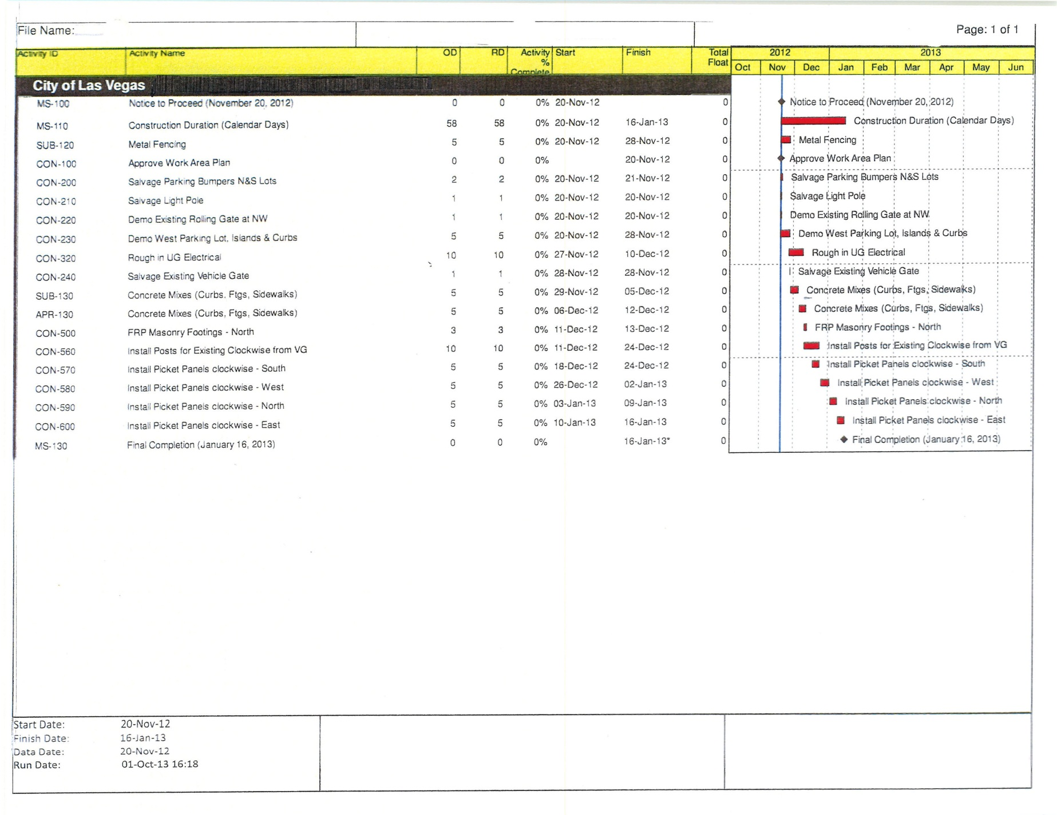 **BASELINE PROJECT SCHEDULE**



