APPENDIX A – PROJECT SIGNS

Note to Spec Writer – Delete the signs you do not need
Front of sign information for City of Las Vegas funded projects: 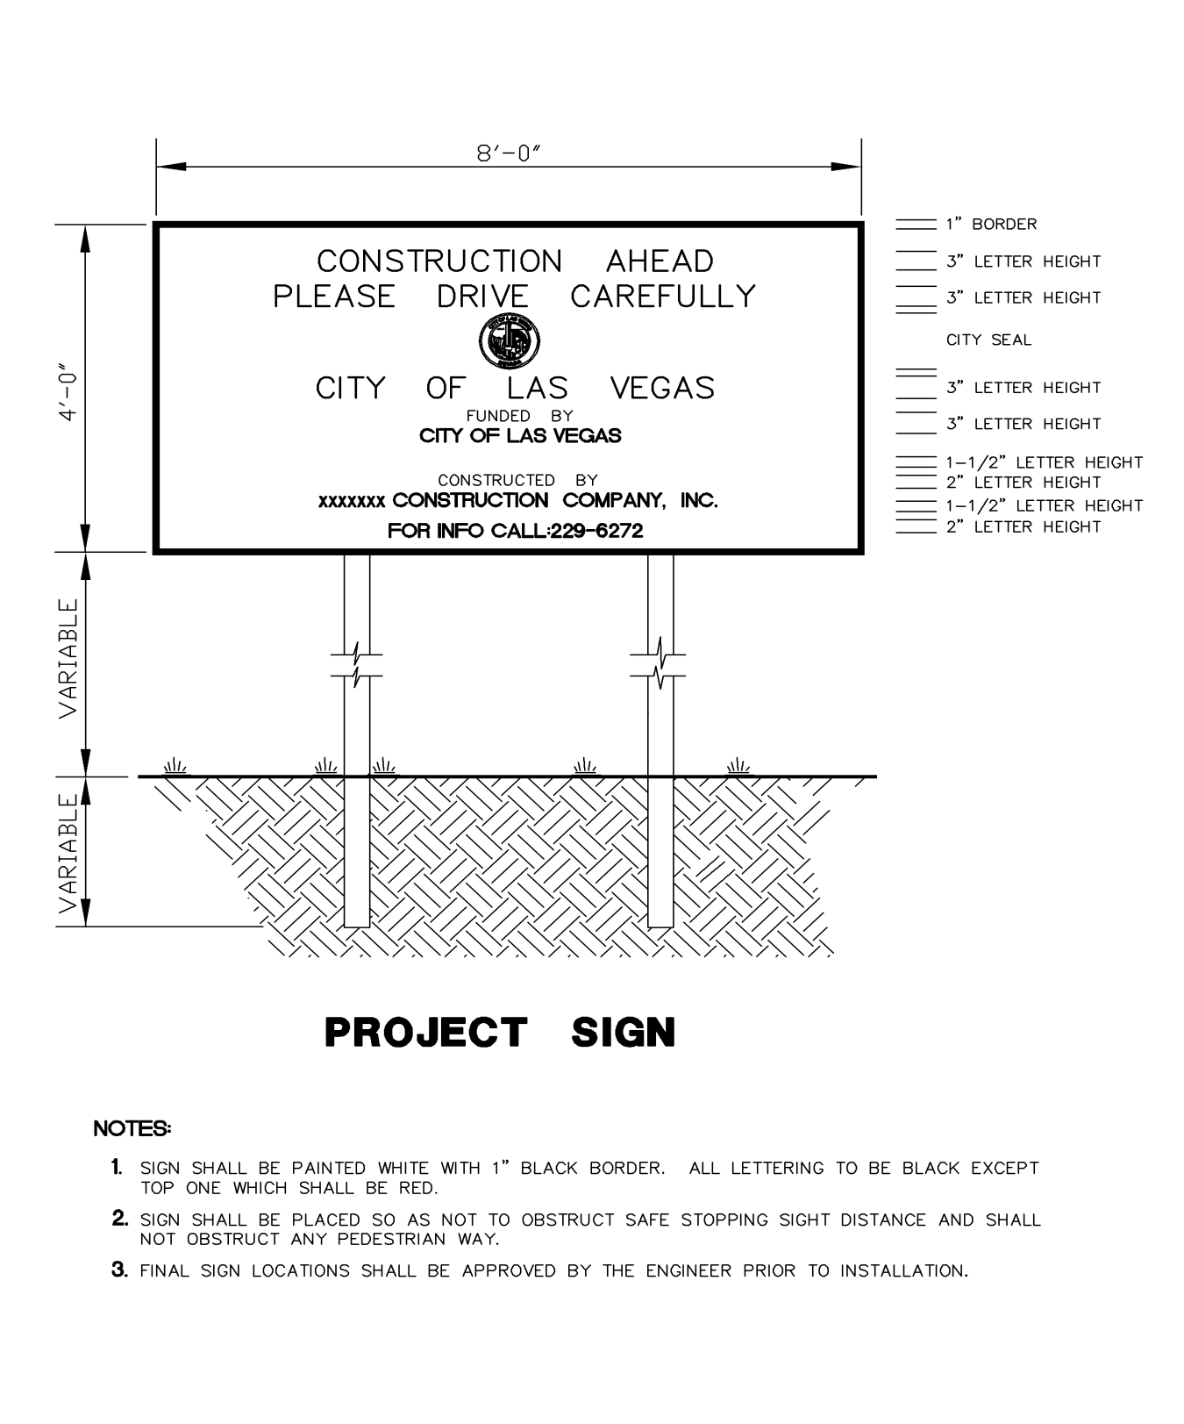
Back of sign information: 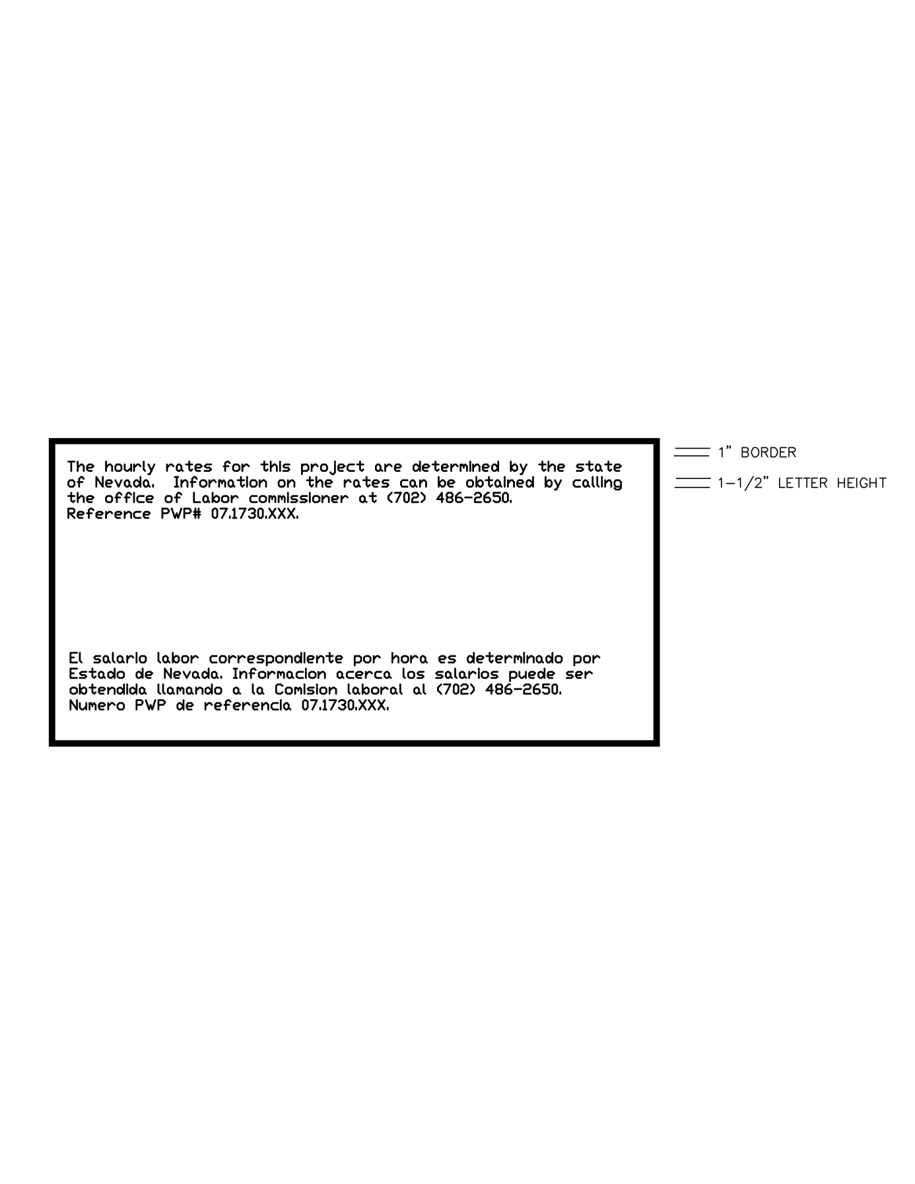

Front of sign information for SNPLMA funded projects:

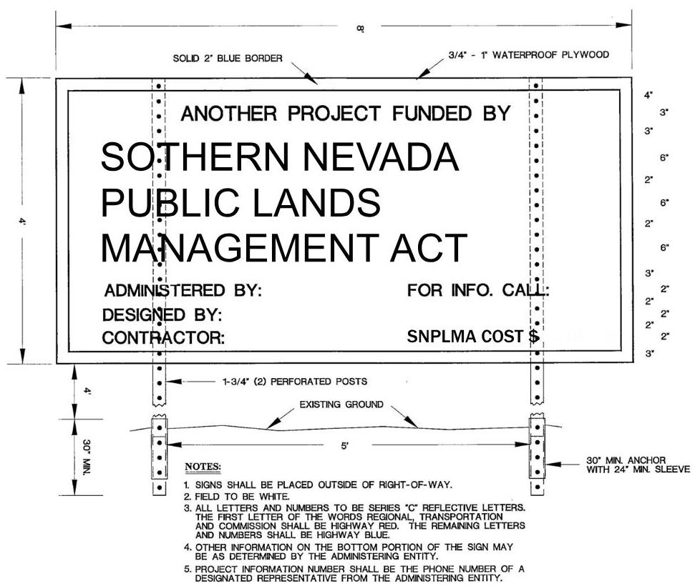

Sign information for RFCD funded projects:
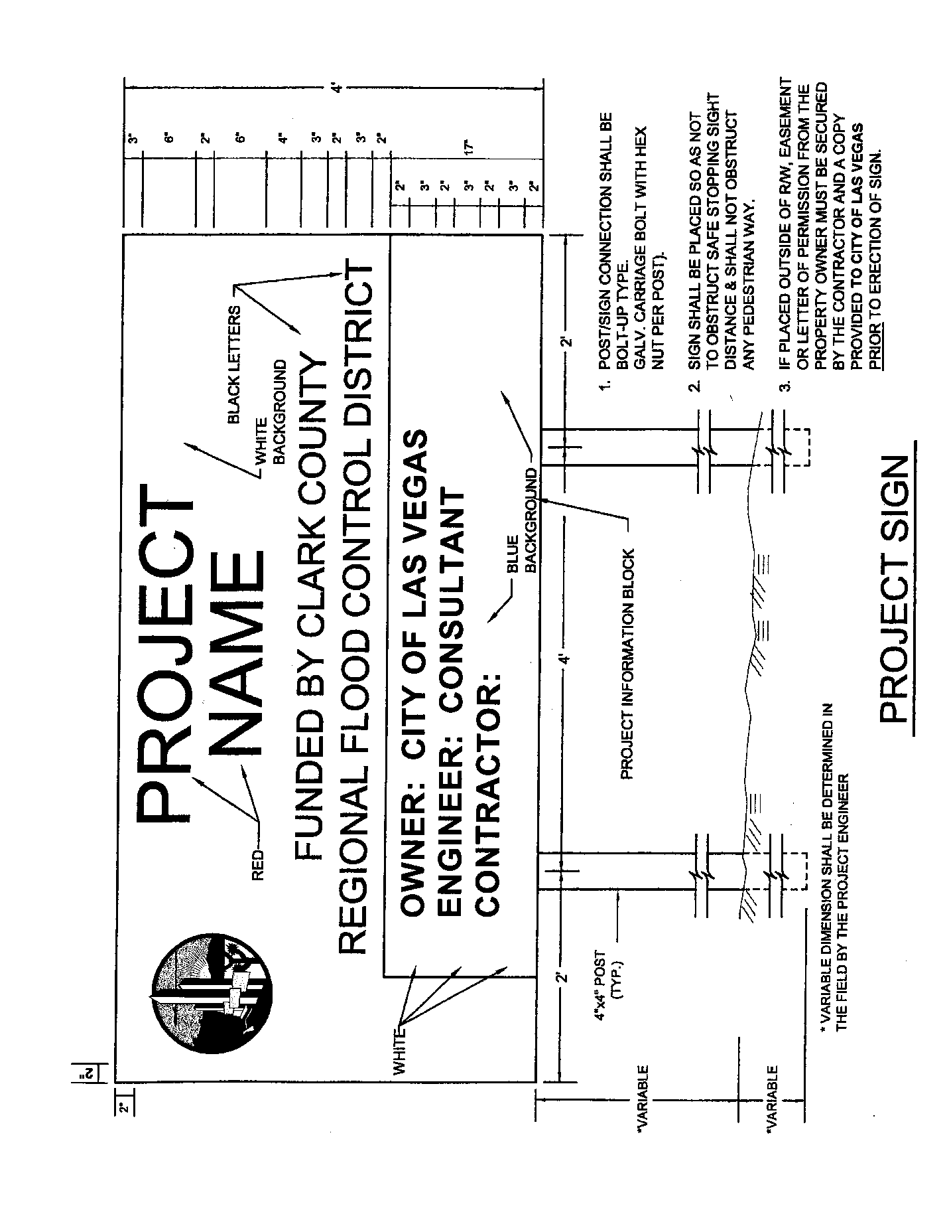
Back of sign (Note to Spec Writer - This is back of sign for all):
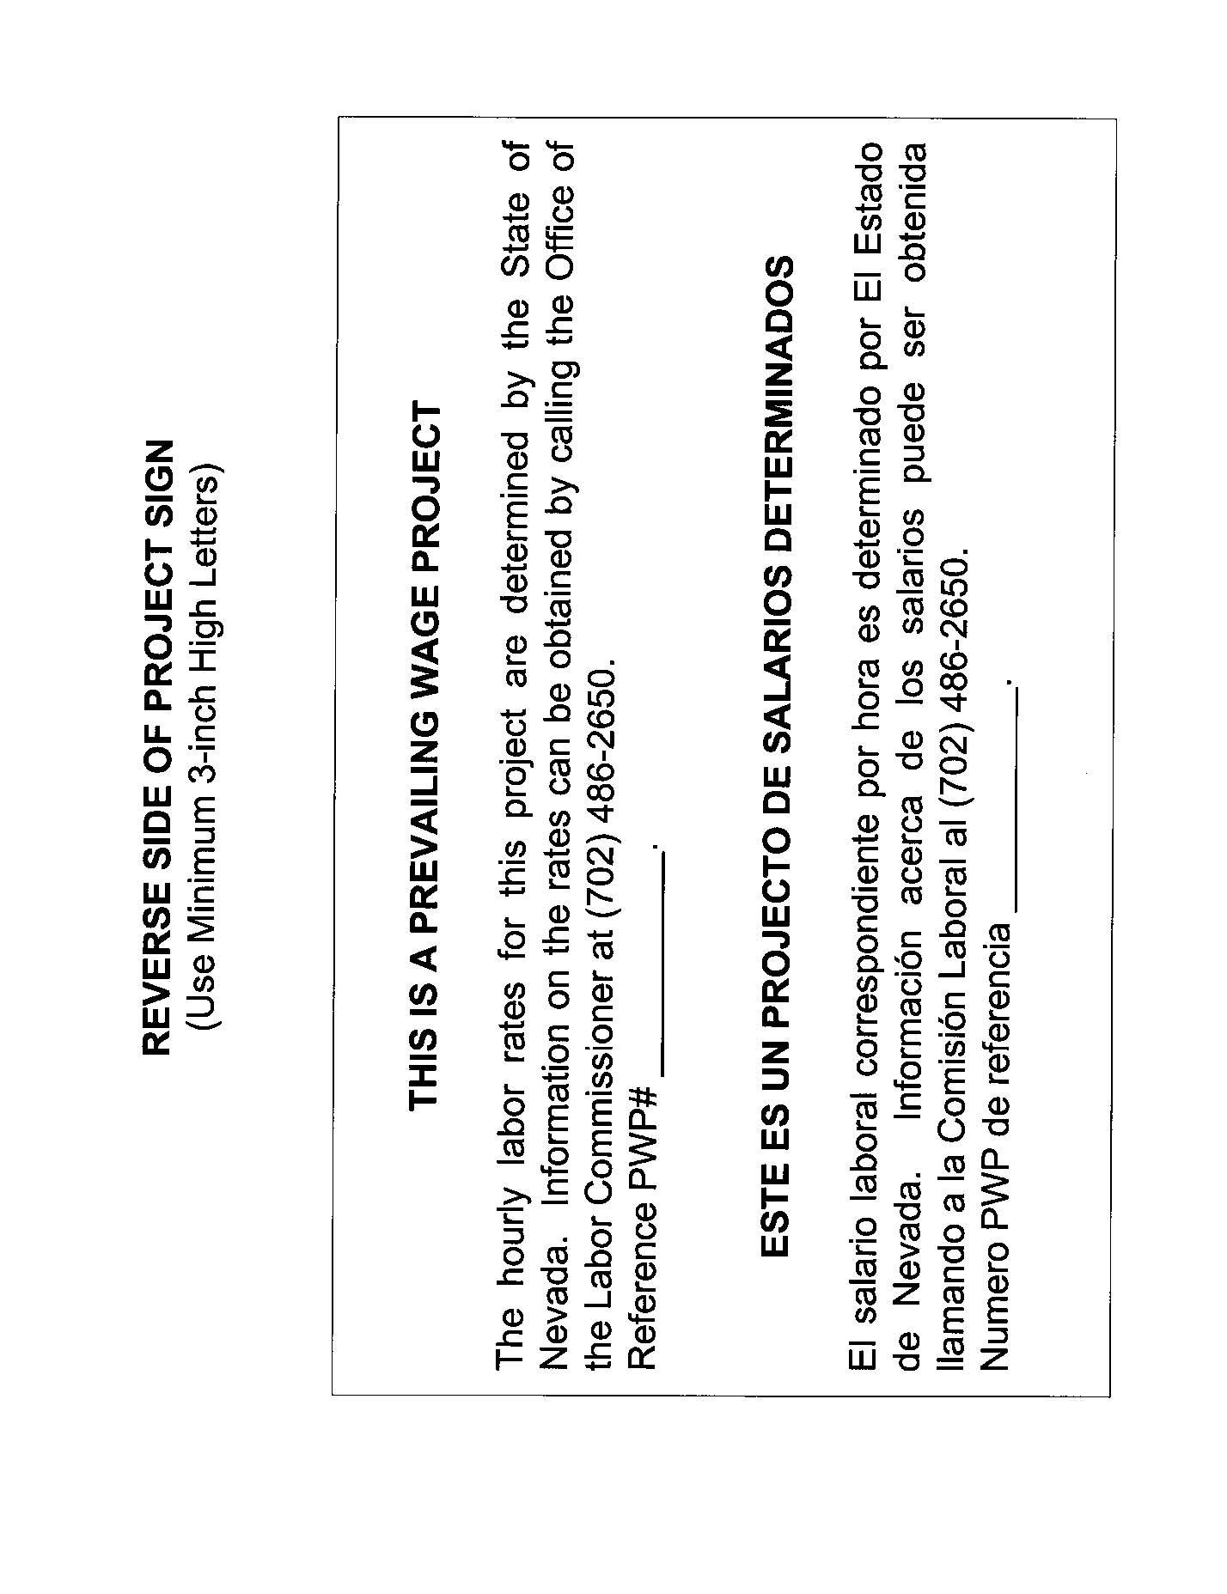
Sign information for RTC funded projects:
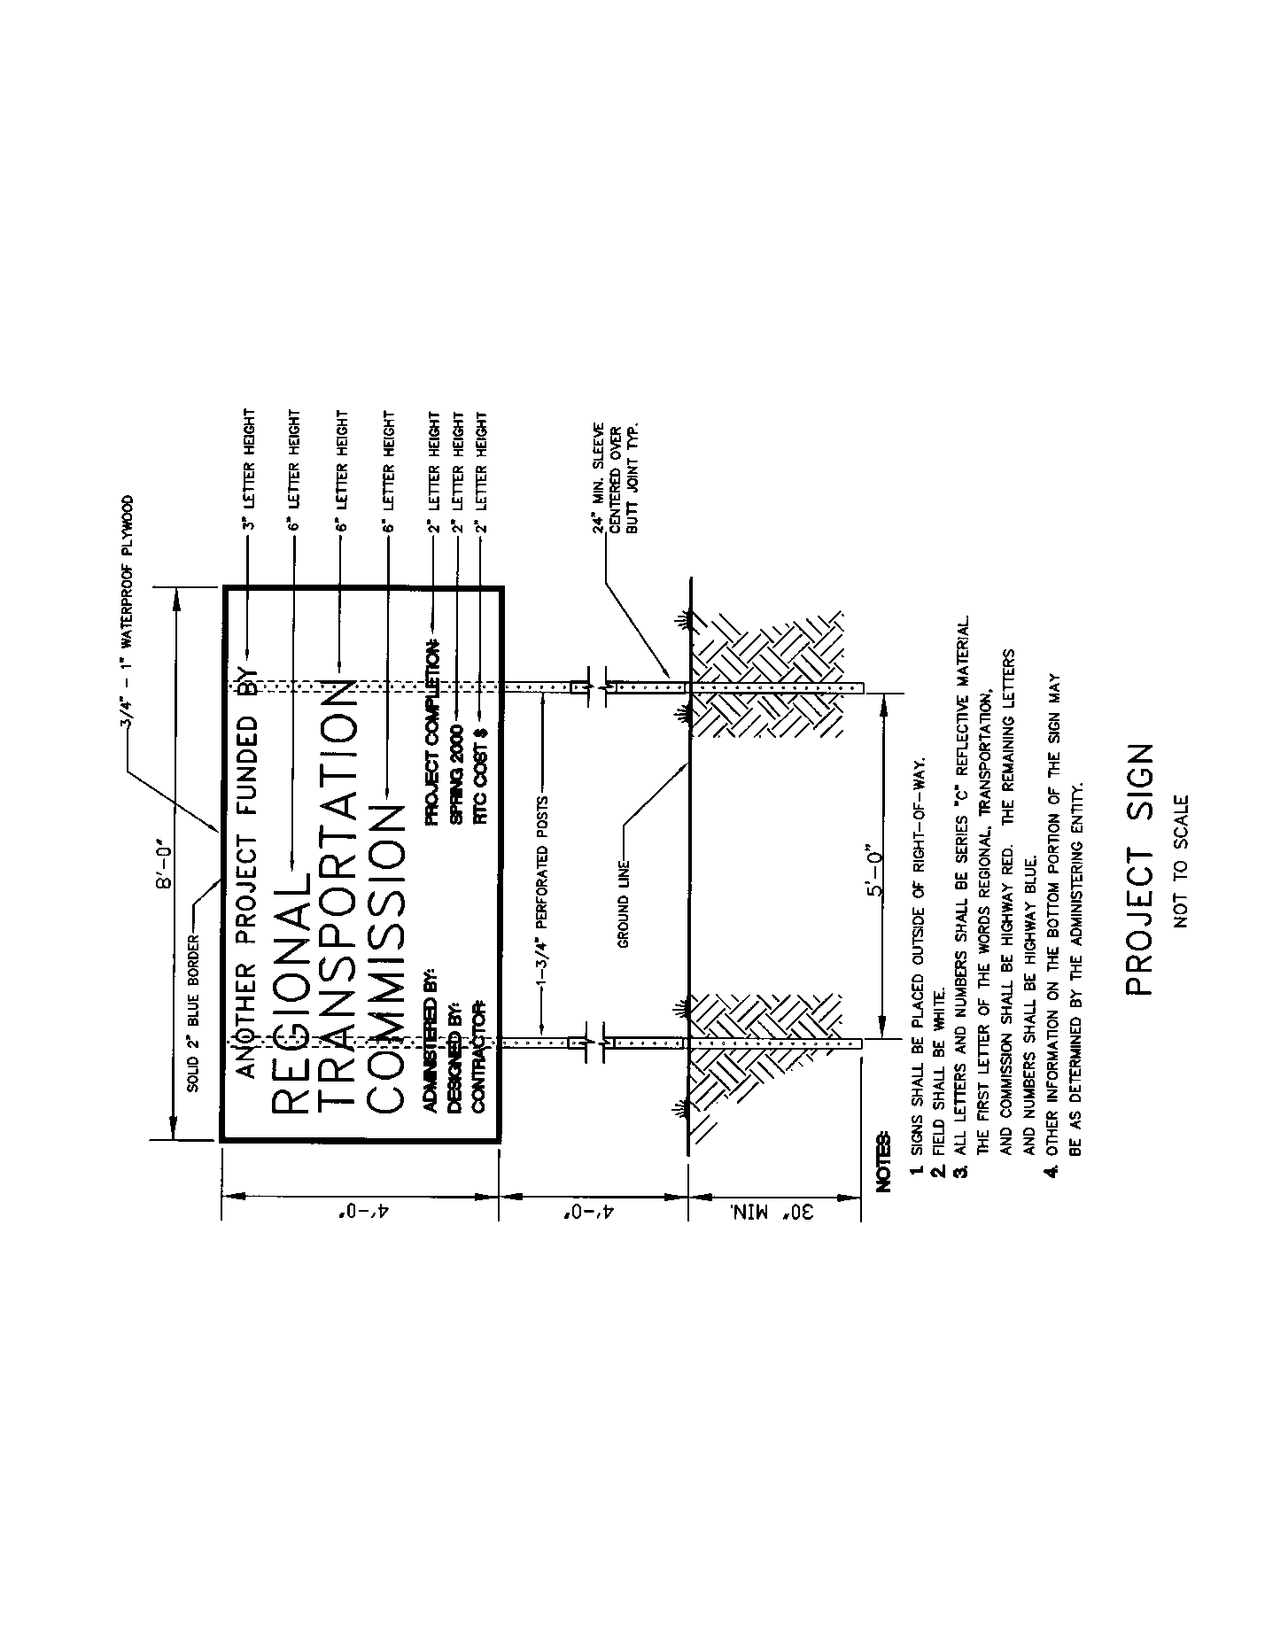
Sign information for RTC and RFCD funded projects:
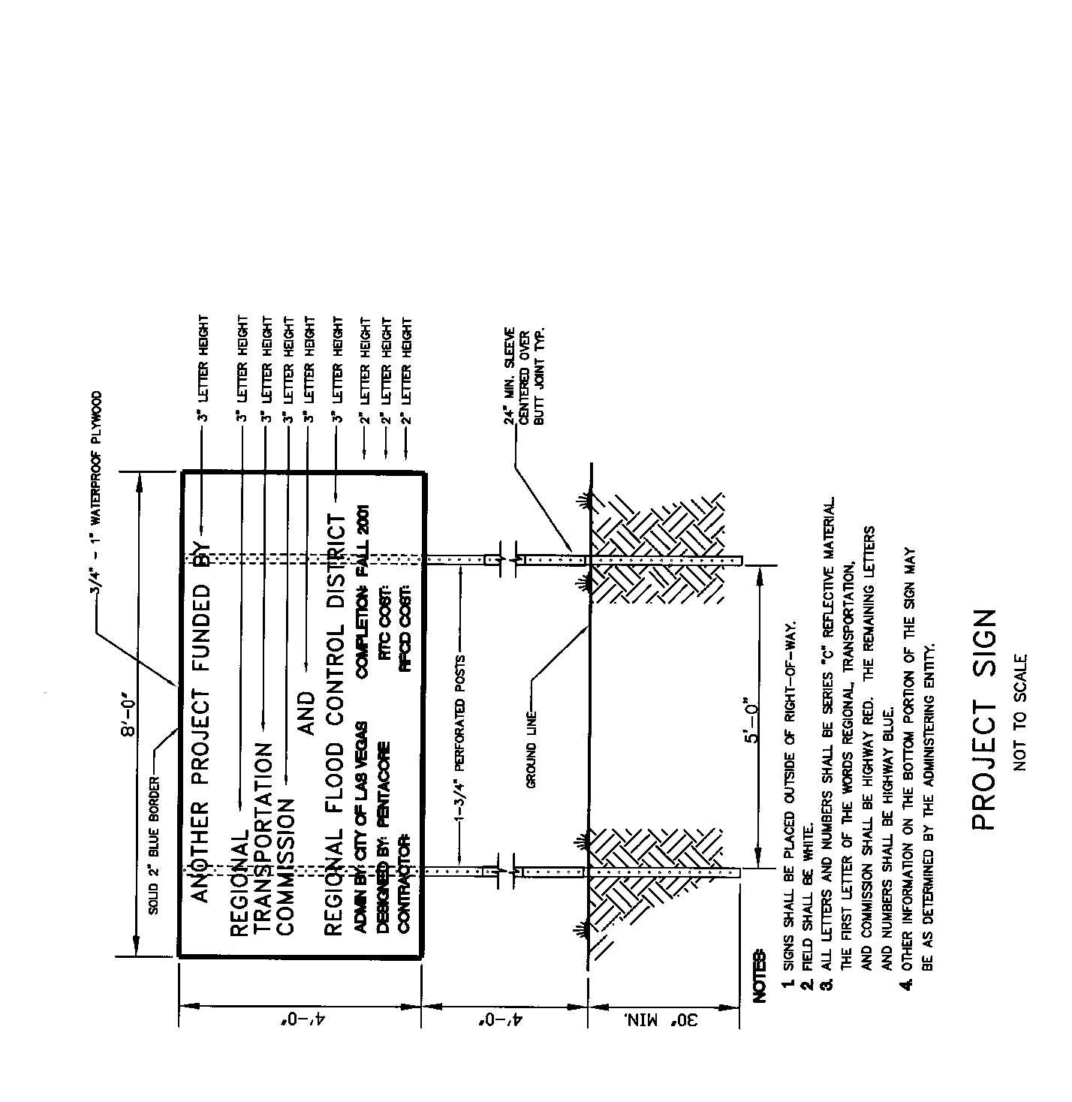

Front of sign information for City of Las Vegas/RTC funded projects:

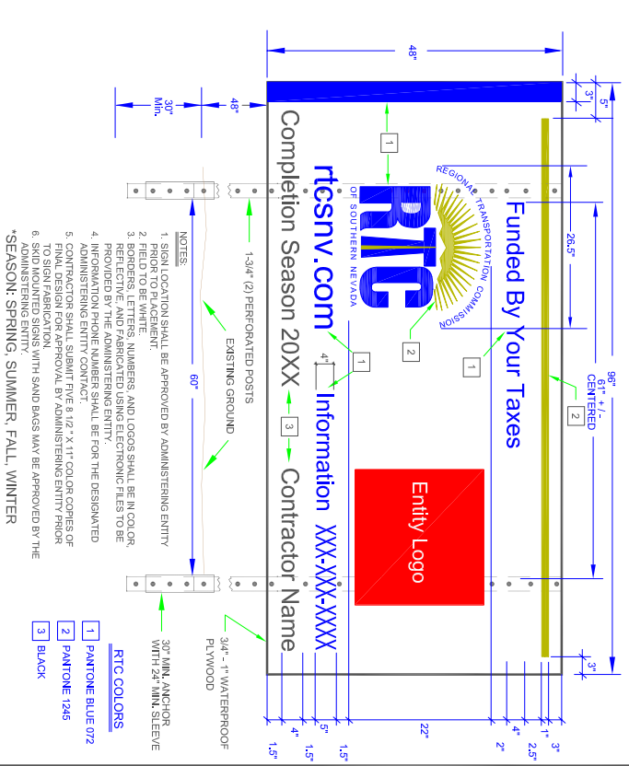
Front of sign information for City of Las Vegas/RTC/ other funded projects:
