Simple Cost Estimate Instructions:
- Navigate to the project tree in masterworks
- Select “Documents” in the project tree
- Click “New”
- Fill in the Title for the image being uploaded and click “Select Files” to initiate the document browser to find your image in your computer. Leave the Workflow drop-down selection as “None”. For your Document Type select “Project Site Details”. (Please note you can only have a single picture with this designation, if you are updating to a newer picture please reclassify, or delete, the existing one. This is the picture we will use in the Annual Report)
- Click “Save”
- Click on “Home” which should be on the bottom left of your screen.
- Click “Enterprise Reports”.
- Double-click “CIP Annual Report”.
- In the Project Name drop-down menu, make sure “(Select All)” is unchecked.
- In the Project Name drop-down menu select your project, which should now be the only project selected. In the Include In Annual Report drop-down menu select “No”. After those drop-down menus are correct, click “View Report”. The page will refresh and give you a Project Summary Sheet which will display the Project Picture you’ve uploaded. This can be printed or Saved as a PDF.
Step-by-Step instructions with pictures start on the next page. <Control+Click here>
- Navigate to the project tree in masterworks
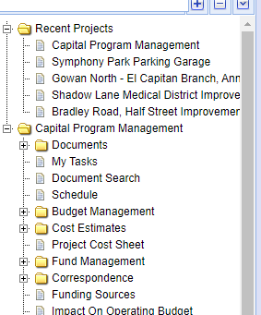

- Select “Documents” in the project tree
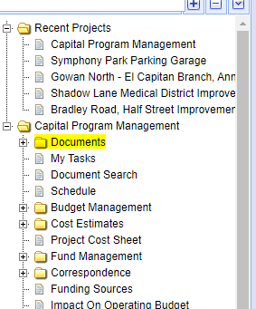

- Click “New”
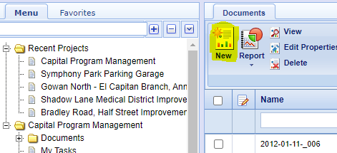

- Fill in the Title for the image being uploaded and click “Select Files” to initiate the document browser to find your image in your computer. Leave the Workflow drop-down selection as “None”. For your Document Type select “Project Site Details”.
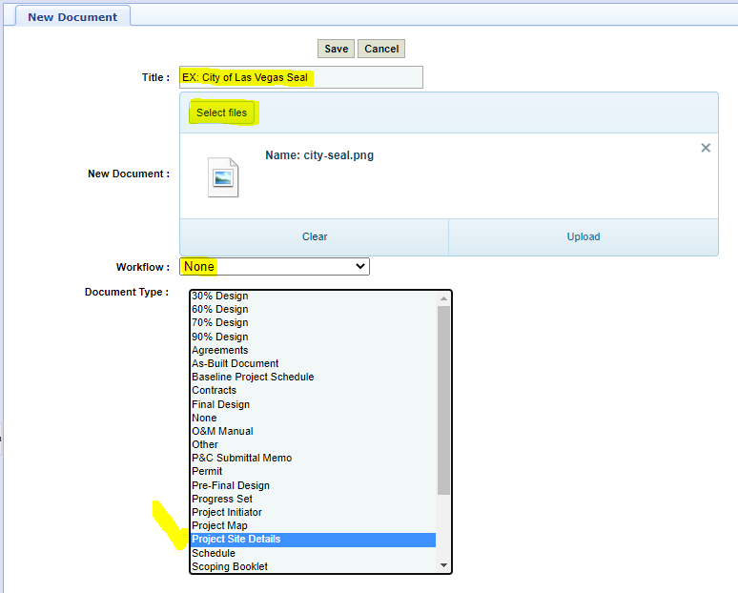

- Click “Save”
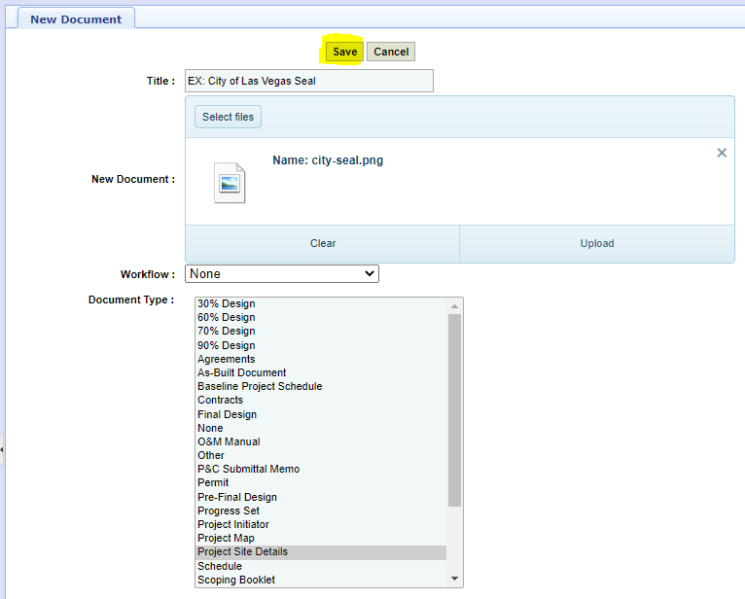

- Click “Home” which should be on the bottom left of your screen.
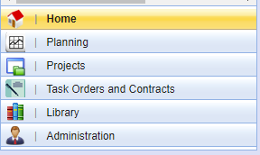

- Click “Enterprise Reports”.
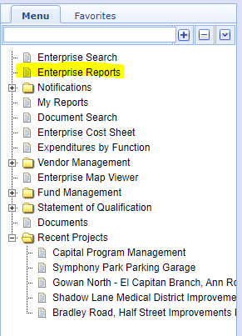

- Double-click “CIP Annual Report”.
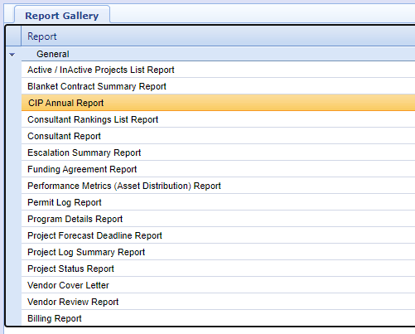

9. In the Project Name drop-down menu, make sure “(Select All)” is unchecked.
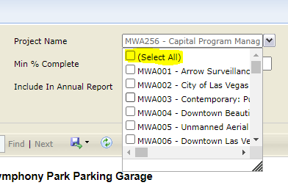

10. In the Project Name drop-down menu select your project, which should now be the only project selected. In the Include In Annual Report drop-down menu select “No”. After those drop-down menus are correct, click “View Report”. The page will refresh and give you a Project Summary Sheet which will display the Project Picture you’ve uploaded. This can be printed or Saved as a PDF.
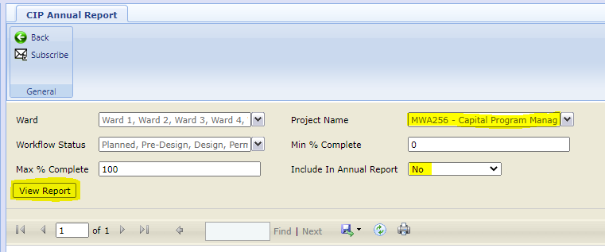
Project Summary Sheet:
